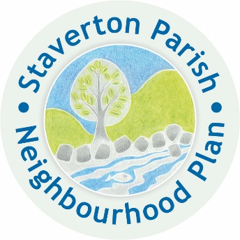
Staverton Parish Neighbourhood Plan

Creating a new vision for the Future

Steering Group Meeting

Monday 6th January 2020 at 7-00

At The Court Room, Staverton

Draft AGENDA

- Apologies for absence

- Approval of notes from the last meeting

- Declarations of interest

- Site allocation

- AOB

- Date of next meeting – Monday February 3rd 2020 at 7-30pm at The Court Room Staverton.

