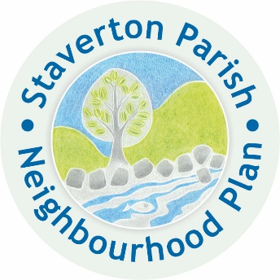
Staverton Parish Neighbourhood Plan

Creating a new vision for the Future

Steering Group Meeting

Tuesday 7th May 2019 at 7-30

At the Live and let Live, landscove

AGENDA

- Apologies for absence

- Approval of notes from the last meeting

- Declarations of interest

- To discuss how Staverton PC’s vote to pledge to make the Parish carbon neutral by 2030 will impact on NP policies. (At the least we will need to look at our Climate Change and Flooding policy direction and without doubt it will impact all our discussions and decisions.)

- To formulate our criteria for site suitability

- Look in more detail at each site with Lee’s report and our criteria to make our choices of sites eventually.

- Financial Update - Chris

